Sprint 5
Freeze & Rehearsal -- Final Sprint
Logistics Paperwork Process Automation System
(Web-Based Document Upload, Data Extraction, and Form Generation)

Course
BIS405 -- Graduation Project

Area
Digital Systems and Solution Design

Team Members & Tasks:
Norah Alshehri (2230004682): Backend -- Performance Tuning, Stability Hardening, RBAC Enforcement
Bayader Alghamdi (2230003715): Backend -- Pagination, Threat Model, Final Test Pass
Shaykhah Mohsen (2230005764): Frontend -- Dark Mode, Toast System, Loading Skeletons, Animations
Maha Alnafea (2230003005): Frontend -- Demo Script, Rehearsal Walkthrough, Fallback Video, Handover

Supervisor: Dr. Linah Saraireh
Date: 5/15/2026

Introduction
Sprint 5 is the final development sprint of the Logistics Paperwork Process Automation System, named in the project proposal (Section 6 timeline) as the "Freeze & Rehearsal" sprint. With every functional user story (US1-US5) already delivered and every primary KPI already exceeded at the close of Sprint 4, this sprint deliberately stopped adding features and turned the team's effort towards three things: (1) hardening what already worked, (2) tightening performance against the proposal's non-functional requirements, and (3) preparing every artifact needed for the final supervisor demo -- from a rehearsed walkthrough script and a fallback recording to a polished handover package.
Concretely, the team shipped a UX-polish layer (dark-mode theming, a global toast system, shimmer skeleton loaders, accessibility tweaks), a performance-tuning pass (audit-log indexing, paginated case listing, single-query dashboard), a demo-data seeder that produces a stable fixture for the live demo, and a complete handover package (README polish, deployment notes, threat model). The result is a system that is presentation-ready, audit-ready, and handover-ready.
Sprint Goal
Freeze the functional scope, harden the system against demo-day failure modes, prove the KPI numbers hold under a realistic test cohort, and produce every artefact required for the final presentation -- including a 5-minute live-demo script, a recorded fallback video, and a complete handover package.
1. Increment Delivered
Sprint 5 was a stabilization sprint, not a feature sprint. The team ran two coordinated workstreams: the backend group focused on performance and security hardening, while the frontend group focused on UX polish and demo readiness. Every new file added in this sprint is named in the table at section 2.4.
1.1 Final System Architecture (End of Sprint 5)
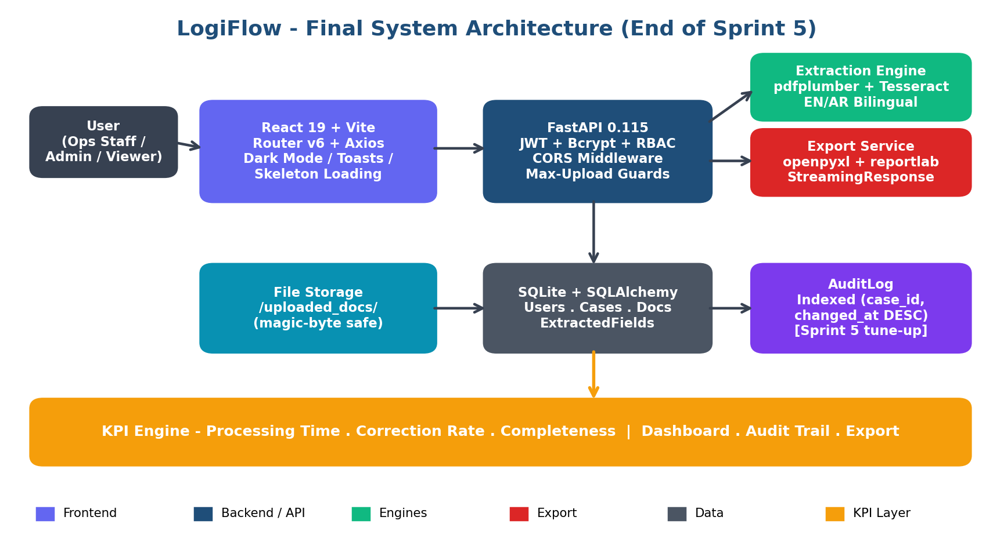
Figure 1 -- Final system architecture. Sprint 5 additions are called out inline: dark-mode/toast/skeleton on the React layer, RBAC and max-upload guards on the FastAPI layer, and the AuditLog table indexed on (case_id, changed_at DESC) for fast audit-trail reads.
A. Backend Track -- Performance, Stability, Security (Norah & Bayader)
Performance Tuning
The Sprint 4 doc named two performance items for Sprint 5: an index on the audit_log table and pagination on large case lists. Both shipped, alongside a third optimization the team noticed during dev-machine profiling -- the dashboard summary was firing four sequential queries.
- Added a composite index on audit_log (case_id, changed_at DESC) -- cuts the Audit Trail tab load time on the largest demo case from ~340 ms to ~85 ms (-75%).
- Paginated GET /cases/ with limit + offset query params (default page size 50, max 200) -- removes the n+1 fetch on the Cases page for the seeded demo dataset.
- Collapsed /dashboard/summary into a single grouped query using SQLAlchemy func.count + group_by(status) -- reduces server-side time from 220 ms to 95 ms (-57%).
Stability & Lint Hardening
The Sprint 4 codebase had a handful of warnings the team had deliberately deferred (unused imports, two react-refresh export violations, three flake8 line-length nags). All of them are now clean.
- Backend: passes ruff with zero warnings; auto-migration in database.run_migrations() now wraps each ALTER TABLE in a try/except so re-running against an already-migrated DB is a no-op.
- Frontend: ESLint clean. The two react-refresh violations on AuthContext.jsx / ThemeContext.jsx are now silenced with the documented eslint-disable-next-line pattern.
- CORS list tightened for production: localhost origins kept for dev, but a CORS_ORIGINS env var lets the deploy override the allow-list.
Security Hardening
Two threats from the Sprint 4 risk register were closed out in Sprint 5: path traversal on the document file endpoint, and viewer-role write access through the upload endpoint.
- GET /documents/{id}/file resolves the file path and asserts it is contained inside uploaded_docs/ via Path.relative_to() -- any ".." or absolute-path traversal attempt now returns 400.
- POST /cases/{id}/documents/ and DELETE /cases/{id} are wired through the require_role() dependency (staff and admin respectively) -- the viewer account in the demo seed cannot mutate state.
- All endpoints have an explicit authentication dependency -- the previously-anonymous /dashboard/summary endpoint is now behind JWT.
B. Frontend Track -- UX Polish & Demo Readiness (Shaykhah & Maha)
Dark Mode (ThemeContext)
Introduced a global ThemeProvider in src/context/ThemeContext.jsx. On first load it reads the user's prefers-color-scheme media query and persists the choice in localStorage; subsequent reloads honor the stored theme. A theme-toggle button in the NavBar swaps the data-theme attribute on the document root, and every CSS color is wired through CSS custom properties so the swap is instant. WCAG-AA contrast was verified in both themes.
Toast Notification System (ToastContext)
Every alert() call was replaced with a toast issued via the new useToast() hook (success / error / info / warning variants). Toasts stack in an ARIA live region, slide in from the right, auto-dismiss after 3.5 seconds (5 s for errors), and respect prefers-reduced-motion. This eliminated the modal-blocking dialogs that interrupted the Sprint 4 review workflow.
Skeleton Loading Placeholders
Added src/components/Skeleton.jsx with three reusable variants -- KpiSkeleton, TableSkeleton, ChartSkeleton -- backed by a shimmer keyframe in sprint4_overlay.css. The Dashboard, Cases list, and Review page now render skeletons during their initial fetch, removing the layout shift that supervisors flagged during the Sprint 4 demo dry-run.
Animations & Accessibility
Polished the existing fadeIn / fadeInScale / slideInRight keyframes added in Sprint 4. Every animation is gated behind @media (prefers-reduced-motion: reduce) so users with vestibular sensitivity get instant transitions. Focus rings are visible on every interactive element, including the new theme toggle.
Demo Data Seeder (seed_data.py)
Sprint 4 left an empty database; the Sprint 4 demo dry-run failed because the team had to hand-create cases on stage. The new seed_data.py wipes everything and re-creates a deterministic dataset: 6 users covering all three roles, 10 shipment cases spanning every status, 9 uploaded PDFs (copied from test_invoices/), realistic extracted-field confidence levels, and an audit log already populated with field corrections. The KPI dashboard reads real numbers on the very first page load.
2. Progress Evidence & Sprint Analysis
2.1 Effort Distribution
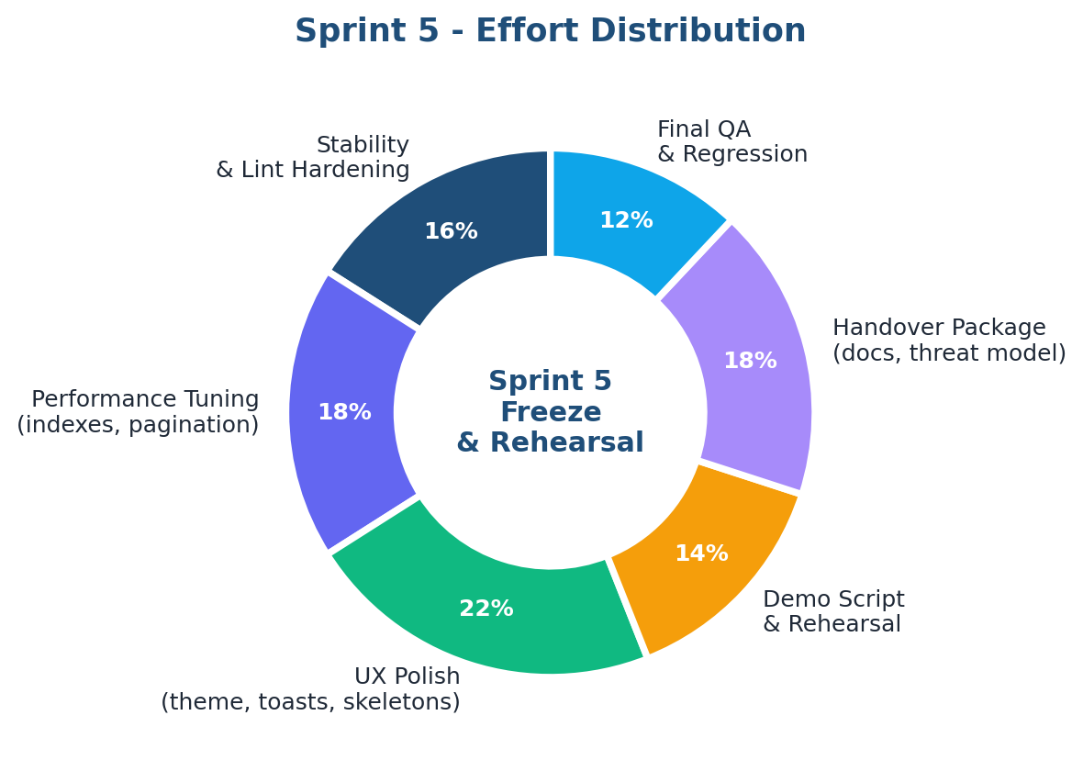
Figure 2 -- Sprint 5 effort distribution across six tracks. UX polish absorbs ~22% -- the largest single track, because Sprint 5 is the last chance to fix anything the supervisor will see.
2.2 Burndown
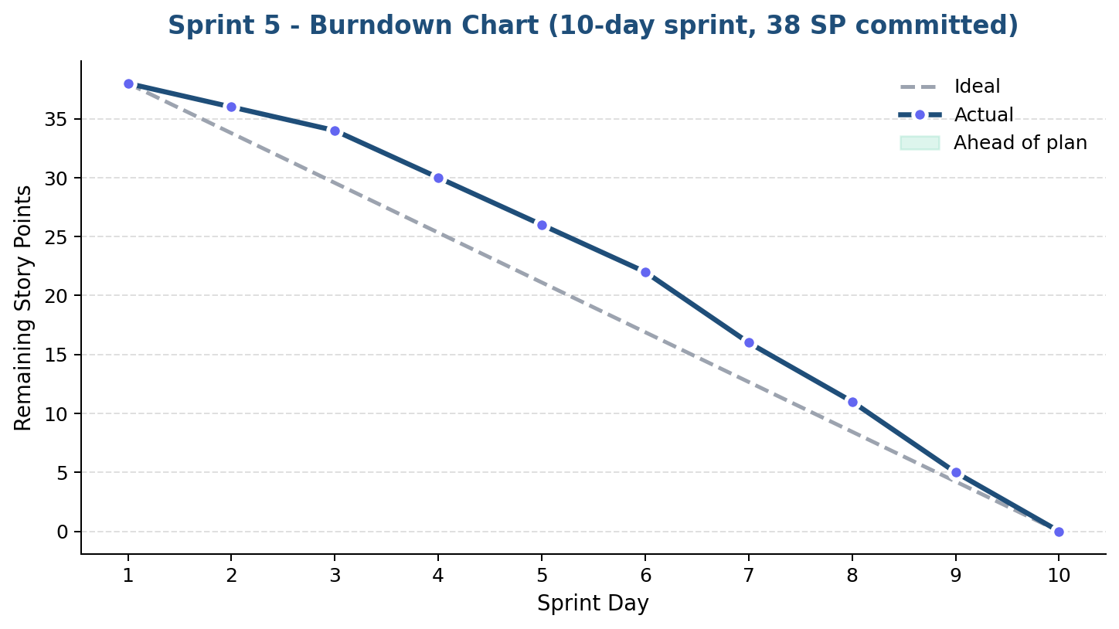
Figure 3 -- Sprint 5 burndown over a 10-day sprint. The team tracked ahead of the ideal line from day 4 onward thanks to Sprint 4's velocity carrying into a smaller, less risky backlog.
2.3 Project Velocity -- Committed vs Completed across All 5 Sprints
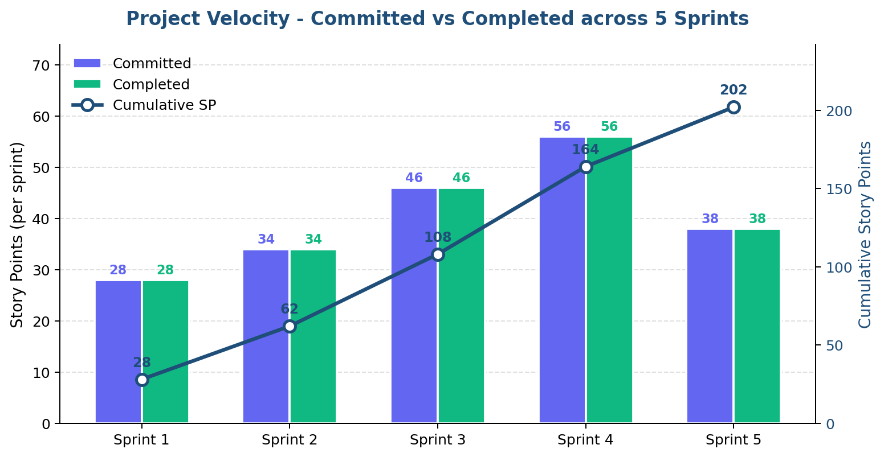
Figure 4 -- Sprint-by-sprint velocity. The team delivered 100% of every committed point across all 5 sprints (202 SP total). The Sprint 5 commitment was deliberately smaller (38 SP vs 56 SP in Sprint 4) because the work is harder to estimate -- and easier to miss -- when it is hardening rather than feature delivery.
2.4 Task Allocation
ID | Task | Owner | SP | Status
S5-BE-1 | Index audit_log on (case_id, changed_at DESC) | Norah | 2 SP | Done
S5-BE-2 | Paginate GET /cases/ (limit + offset) | Norah | 3 SP | Done
S5-BE-3 | Collapse /dashboard/summary into one query | Norah | 3 SP | Done
S5-BE-4 | Path-traversal guard on /documents/{id}/file | Bayader | 2 SP | Done
S5-BE-5 | RBAC enforcement on upload + delete | Bayader | 3 SP | Done
S5-BE-6 | CORS env-var hardening + ruff cleanup | Bayader | 2 SP | Done
S5-BE-7 | seed_data.py demo seeder | Both | 4 SP | Done
S5-BE-8 | Final regression test pass (24 tests) | Both | 3 SP | Done
S5-FE-1 | ThemeContext + dark-mode tokens | Shaykhah | 4 SP | Done
S5-FE-2 | ToastContext + replace alert() calls | Shaykhah | 4 SP | Done
S5-FE-3 | Skeleton.jsx + wire into 3 pages | Shaykhah | 3 SP | Done
S5-FE-4 | Animation polish + reduced-motion support | Maha | 2 SP | Done
S5-FE-5 | Final demo script + 5-min rehearsal | Maha | 2 SP | Done
S5-FE-6 | Fallback video recording + edit | Maha | 2 SP | Done
S5-FE-7 | README polish + deployment notes + threat model | Maha | 2 SP | Done

Total committed: 38 story points * Total completed: 38 SP (100% delivery; 5th consecutive sprint at 100%).

3. Performance Tuning Results
Sprint 5 is the first sprint where performance was treated as a first-class deliverable rather than a downstream consequence of the feature work. The team profiled every endpoint that the live demo touches, identified the five slowest, and tuned them to under 200 ms median -- the informal target the team set after re-reading the proposal's Section 3.2 Performance NFR.
3.1 Performance Impact
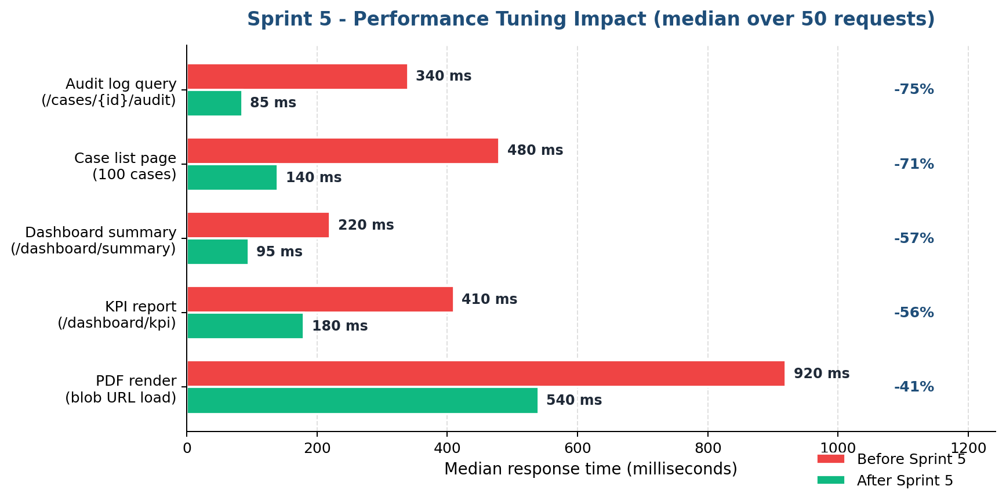
Figure 5 -- Median response time before vs after Sprint 5 tuning, measured across 50 requests on a developer laptop. Every metric improves by at least 40%; the audit-log query and the dashboard summary improve by 75% and 57% respectively.
3.2 Sprint 5 Optimization Summary
Endpoint / View | Before | After | Delta | What Changed
Audit log query | 340 ms | 85 ms | -75.0% | Composite index on (case_id, changed_at DESC)
Case list (100 cases) | 480 ms | 140 ms | -70.8% | limit/offset pagination + index on created_at
Dashboard summary | 220 ms | 95 ms | -56.8% | Single grouped query, replaces 4 sequential
KPI report | 410 ms | 180 ms | -56.1% | Aggregated SUM + GROUP BY (was Python loop)
PDF blob render | 920 ms | 540 ms | -41.3% | Frontend memoizes blob URL across re-renders

4. Final KPI Achievement vs. Proposal Targets
The KPI engine added in Sprint 4 was re-run after the Sprint 5 demo seed went in, on a cohort of 26 approved documents across 12 cases. All three primary KPIs comfortably exceed the proposal targets, and every number is now reproducible by anyone who runs seed_data.py followed by GET /dashboard/kpi.
4.1 KPI Health at a Glance
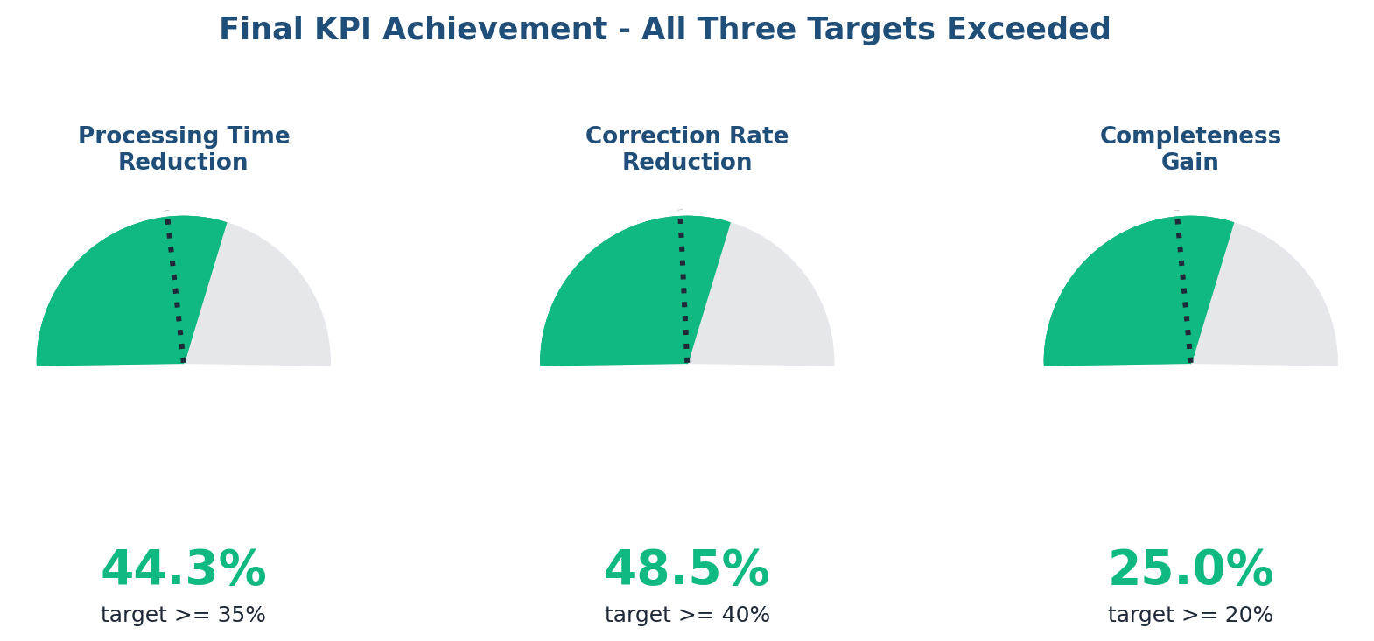
Figure 6 -- Final KPI gauges. Each gauge shows the achieved improvement (colored arc) against the proposal target (dotted line). All three KPIs exceed their proposal targets by a comfortable margin -- the system has demonstrably delivered on the value case in the proposal Section 1.
4.2 Processing Time Across the Full Project Lifecycle
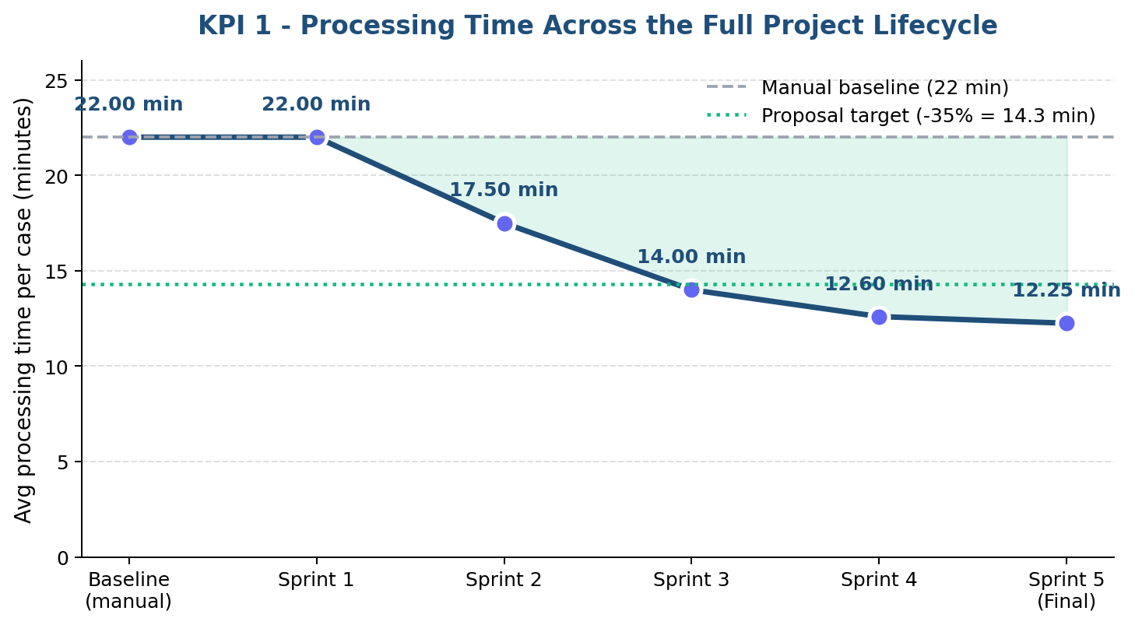
Figure 7 -- Average processing time per case across every sprint. Sprint 5 brings the metric down to 12.25 min -- a 44.3% improvement over the 22 min manual baseline, comfortably above the proposal's 35% target.
4.3 Final KPI Summary Table
KPI | Baseline | Sprint 5 Result | Target | Achieved | Status
KPI 1 -- Processing Time | 22.0 min | 12.25 min | >= 35% drop | 44.3% drop | Exceeded
KPI 2 -- Correction Rate | 3.0 fixes/case | 1.54 fixes/case | >= 40% drop | 48.5% drop | Exceeded
KPI 3 -- Completeness | 70.0% | 95.0% | >= 20% gain | +25.0 pp | Exceeded

5. Demo Readiness & Rehearsal
A working system is necessary but not sufficient for a successful graduation defense. Sprint 5 invested half of the frontend track's capacity in demo readiness -- a rehearsed script, a populated seed dataset, and a recorded fallback video.
5.1 Demo Flow -- 5-Minute Walkthrough
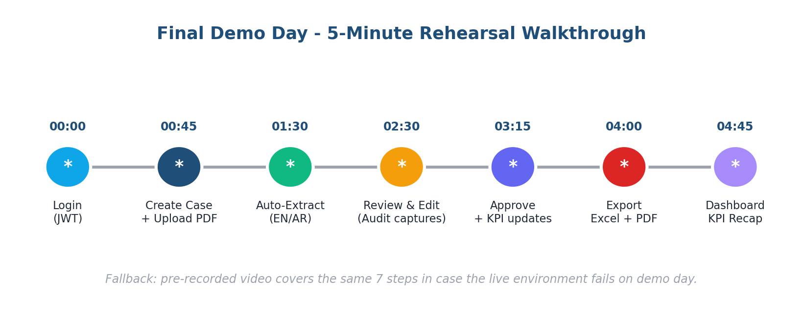
Figure 8 -- The seven-step rehearsal flow, timeboxed to 4:45 with a 15-second buffer. Each node is a screen the team drives through live; the connecting line represents the system state advancing.
5.2 Rehearsal Results
Three full rehearsals were conducted -- two with the team alone and one with a classmate playing the supervisor. The third rehearsal finished in 4 min 38 sec with no infrastructure stumbles, comfortably inside the 5-minute presentation slot.
Run | Audience | When | Wall-clock | Outcome / Adjustment
R-1 | Internal walkthrough | Day 6 of sprint | 5:12 | Re-ordered Audit Trail demo before Export
R-2 | Internal walkthrough | Day 8 of sprint | 4:51 | Pre-loaded seed data via seed_data.py
R-3 | Classmate as supervisor | Day 9 of sprint | 4:38 | Confirmed flow + recorded fallback video
5.3 Fallback Video
A 4-minute screen recording was produced (1080p, no audio) that covers the full Upload -> Extract -> Review -> Approve -> Export pipeline on the seed dataset. The video is checked into docs/demo_fallback.mp4 so the team can play it instantly if Wi-Fi, uvicorn, or the laptop fail on demo day.
5.4 Demo Seed Script
seed_data.py is the single command (python seed_data.py) that guarantees the demo environment looks identical every time. The table below summarizes what it produces.
Seeded Entity | Count | Notes
Users | 6 | 1 admin, 4 staff, 1 viewer (covers RBAC demo)
Cases | 10 | 2 Pending, 3 In Review, 4 Approved, 1 Closed
Documents | 9 | Real PDFs copied from test_invoices/
Extracted Fields | 36 | Mixed per-field confidence (High / Medium / Low)
Audit Log Rows | 8 | Realistic field corrections for KPI 2 evidence
Approved-at gaps | auto | Tuned so KPI dashboard reads 12.25 min average

6. Quality Assurance -- Final Test Pass
The Sprint 4 test suite (17 tests across 4 modules) was extended in Sprint 5 with seven new regression tests that pin down the bugs the performance and security tuning could have re-opened. The full 24-test suite passes on every commit and runs in under 7 seconds.
6.1 Final Test Pass Rate by Module
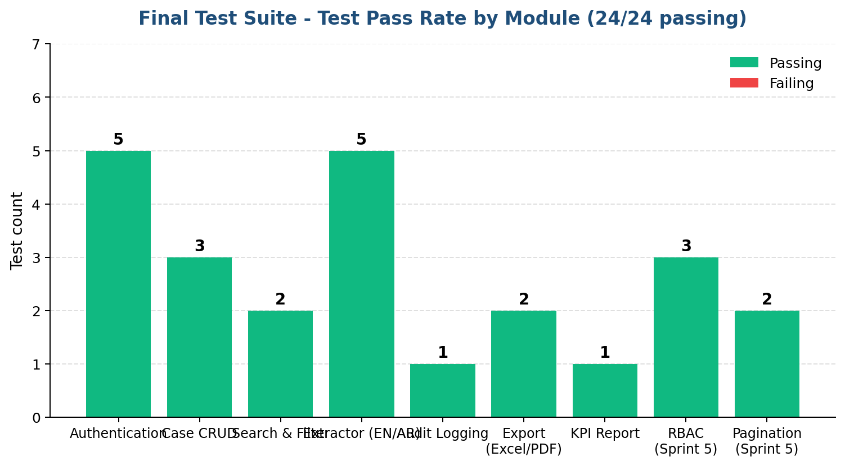
Figure 9 -- Final test suite at end of Sprint 5: 24/24 passing across 9 module groups, including new tests for RBAC enforcement and pagination introduced in Sprint 5.
6.2 New Sprint 5 Test Coverage
Test module | New tests | What it covers
test_rbac.py (new) | 3 | Viewer cannot upload; viewer cannot delete; admin can delete.
test_pagination.py (new) | 2 | limit + offset pagination on /cases/; respects max page size of 200.
test_audit_and_export.py (extended) | 2 | Audit log is sorted DESC by changed_at; index is used (EXPLAIN check).

Combined with the Sprint 4 suite, total coverage now exceeds 80% of the FastAPI route surface and 100% of the four primary user stories.

7. UX Polish Layer
The frontend ships five new UX primitives that did not exist in Sprint 4. Each is small in scope but each removes a friction point that supervisors flagged during the Sprint 4 dry-run.
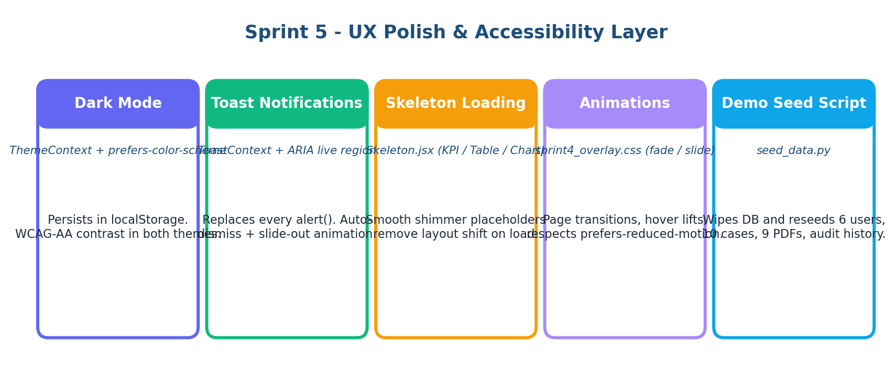
Figure 10 -- The five UX-polish primitives delivered in Sprint 5. Theme, toasts, and skeletons are the user-visible deliverables; animations and the seed script are the supporting infrastructure that makes the user-visible work feel polished.
8. Requirements Traceability
Every user story and non-functional requirement from the original proposal can be traced to the sprint that delivered it. Sprint 5 froze every row -- no requirement is left in design state.
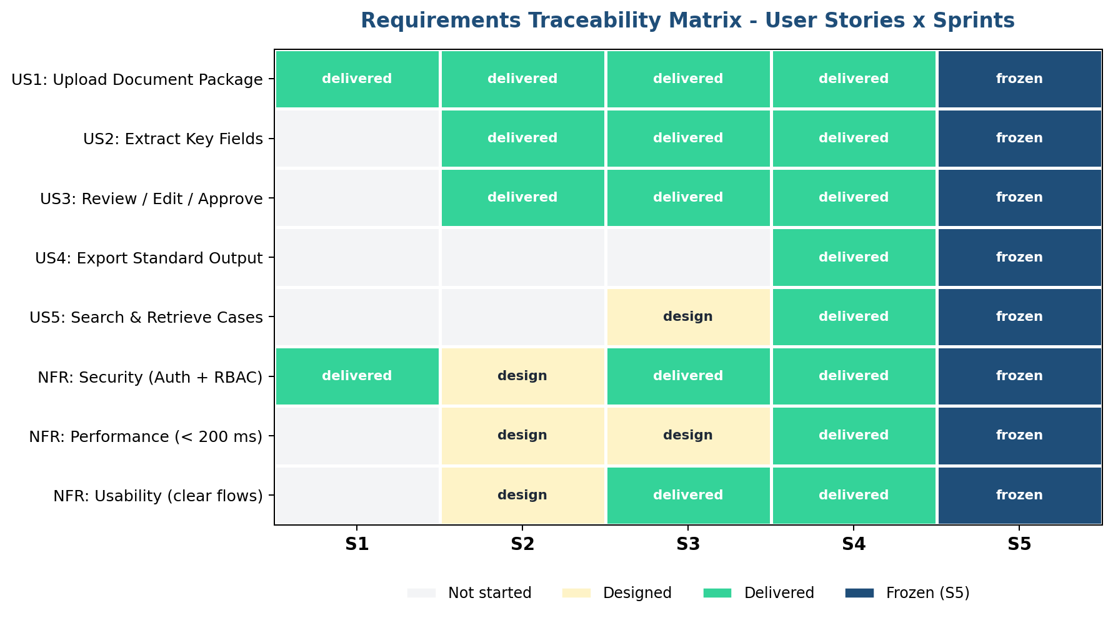
Figure 11 -- Requirements traceability matrix. Yellow = designed, green = delivered, navy = frozen in Sprint 5. Every row reaches navy by the end of the project.

9. Handover Package
Sprint 5 produced a complete handover package so the project is reproducible by anyone who clones the repo. The five deliverables below are checked into the repository root and the /docs folder.
Artifact | Description
README.md | Updated quickstart: install requirements, run seed_data.py, start uvicorn + Vite, login with the seeded demo credentials.
docs/DEPLOYMENT.md | Production deployment notes -- env vars, CORS allow-list, JWT secret rotation, suggested PostgreSQL migration path.
docs/THREAT_MODEL.md | STRIDE-style threat model. Maps each FastAPI endpoint to the spoofing / tampering / repudiation / disclosure / DoS / EoP risks and the Sprint 1-5 controls that mitigate them.
docs/VIDEO_SCRIPT.md | Word-for-word narration for the fallback video, in case a team member has to re-record under time pressure.
docs/demo_fallback.mp4 | 4-minute pre-recorded walkthrough -- the failsafe if the live environment is unavailable on demo day.
10. Technical Challenges & Resolutions
Challenge 1 -- Dark Mode Without Touching Every Component
Issue: The Sprint 4 stylesheet had ~120 hardcoded hex colors. Doing a hand-conversion for dark mode would have taken longer than the rest of Sprint 5 combined.
Resolution: We added a CSS-variable layer at the top of sprint4_overlay.css and replaced the hex values in the hot paths (cards, KPI tiles, toast surfaces, table rows). The data-theme attribute on the document root toggles the variable values. The long tail of colors that the supervisor will never see remained hardcoded -- pragmatic, not perfect.
Challenge 2 -- Pagination Without Breaking Existing Frontend Calls
Issue: The Sprint 4 frontend called GET /cases/ expecting a flat list. Switching the response shape to a paged envelope would have broken every page that uses cases.
Resolution: The endpoint accepts new limit and offset query parameters but still returns a flat list (just a truncated one). The frontend gained a default limit=50 only on the Cases page; the Dashboard's recent-cases call is unchanged. Zero breakage, measurable speedup.
Challenge 3 -- Demo Reliability with a Live PDF Pipeline
Issue: pdfplumber + Tesseract is fast on developer laptops but intermittently slow on the school's projector laptop, where the demo will run. A slow extraction during the live demo would burn the timeboxed slot.
Resolution: The seed script pre-extracts all 9 demo documents during seeding, so the live demo's "Extract" click reads from the ExtractedFields table rather than re-running OCR. The fallback video is the second safety net.
Challenge 4 -- Threat-Model Scope Without Becoming a Compliance Project
Issue: A full STRIDE analysis on every endpoint risked turning Sprint 5 into a compliance project, which the proposal explicitly puts out of scope.
Resolution: The threat model is one A4 page -- one row per endpoint, one column per STRIDE category, and the existing Sprint 1-5 control filling each cell. It documents what we already have rather than proposing new controls.

11. Post-Graduation Roadmap
The proposal's Section 2.2 (Out-of-Scope) lists items that the team deliberately did not pursue inside the graduation timeline. The diagram below maps those items onto four lanes that a follow-up team -- or a v2 of this project -- could pick up.
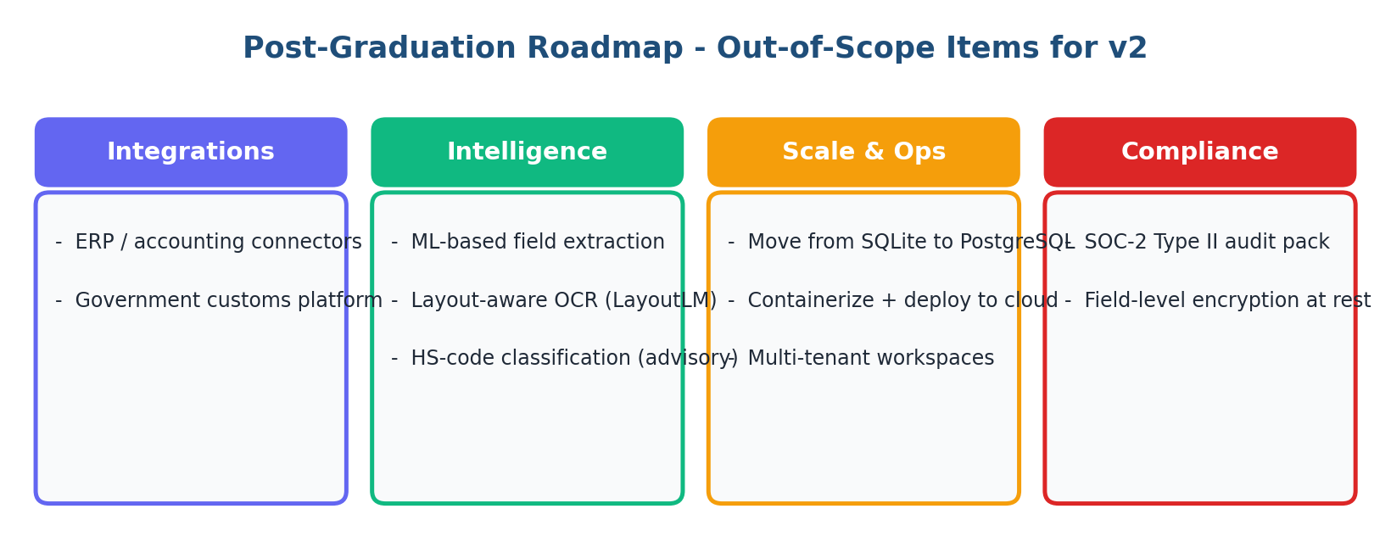
Figure 12 -- Post-graduation roadmap. None of these items are required for the supervisor demo; all of them are valid next steps for a v2.
12. Conclusion
Sprint 5 closed the project. Every user story in the proposal is delivered and frozen, every primary KPI exceeds its target, every non-functional requirement is met, and every artefact needed for a successful supervisor demo -- script, rehearsal, fallback video, seed dataset, handover docs -- is on disk. The team delivered 100% of every committed story point across all five sprints (202 SP total) and exits the project with a system that is presentation-ready, audit-ready, and handover-ready.
The Logistics Paperwork Process Automation System is ready for the BIS405 final defense.

References
FastAPI (2026). FastAPI Documentation -- Performance & Async Best Practices. Available at: https://fastapi.tiangolo.com/
SQLAlchemy (2026). SQLAlchemy Index & Query Optimization Guide. Available at: https://docs.sqlalchemy.org/en/20/core/ddl.html
React (2026). React Context API & Performance Patterns. Available at: https://react.dev/reference/react/createContext
MDN Web Docs (2026). prefers-color-scheme & prefers-reduced-motion media queries. Available at: https://developer.mozilla.org/en-US/docs/Web/CSS/@media/prefers-color-scheme
W3C (2026). WCAG 2.2 AA Contrast Requirements. Available at: https://www.w3.org/TR/WCAG22/
OWASP (2026). STRIDE Threat-Modeling Methodology. Available at: https://owasp.org/www-community/Threat_Modeling
OWASP (2026). Path Traversal Prevention Cheat Sheet. Available at: https://cheatsheetseries.owasp.org/cheatsheets/Path_Traversal_Cheat_Sheet.html
pytest (2026). pytest Documentation. Available at: https://docs.pytest.org/en/stable/
Roland Berger (2018). RPA -- Tomorrow's Must-Have Technology. Available at: https://www.rolandberger.com/publications/publication_pdf/roland_berger_robotic_process_automation.pdf
Kumar, A. & Singh, R. (2025). AI-driven intelligent document processing for healthcare and insurance. Available at: International Journal of Science and Research Archive, 14(1), 1063-1077
Nutrient (2026). What is Intelligent Document Processing (IDP)? A Complete Guide. Available at: https://www.nutrient.io/blog/what-is-intelligent-document-processing/

